STAFFORD JUNIOR SCHOOL

PRIMARY PE AND SPORT PREMIUM PLAN FOR
2022-23

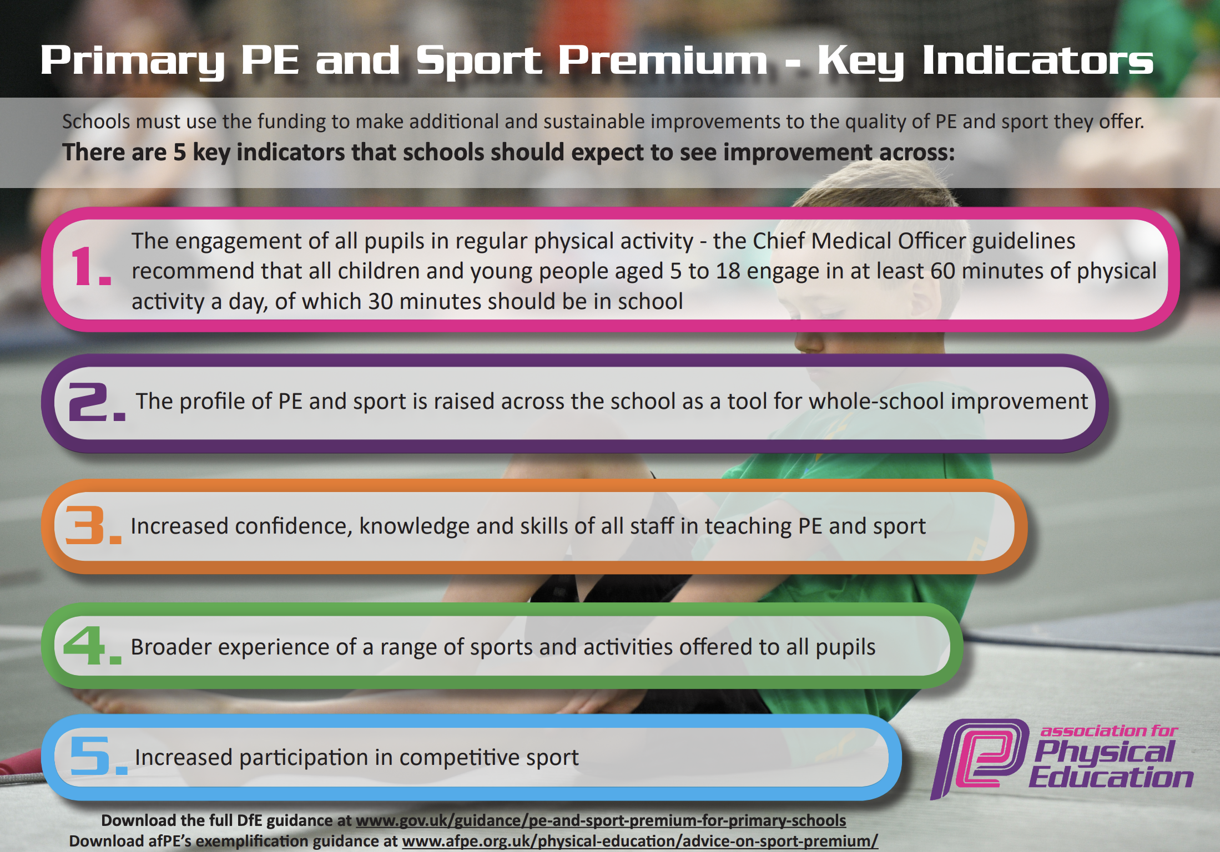
Support for review and reflection - considering the 5 key indicators from DfE, what development needs are a priority for your setting and your students now and why? Use the space below to reflect on previous spend, identify current need and priorities for the future.

Key achievements to date: | Areas for further improvement and baseline evidence of need:
- Real PE (Jasmine) further developed and embedded within the school curriculum - Legacy school  - Whole school Staff CPD on all aspects of Real PE programme  - Consistent teaching following the Real PE programme  - Specialist PE coach support - including active lunchtimes and also widening the range of sporting opportunities - eg orienteering  - Specialist Forest School support  - A range of pupils have participated in a range of competitive events.  - Successful sports days completed for all year groups  - School Games Mark Gold Award achieved in 2018-19  - Highly effective collaboration has taken place between PE leaders across the Federation & the Cavendish partnership  - Increased range of sports club offered to all pupils  - Active playtimes encouraged through Sports Coach supporting MDSA supervised football, hockey, tennis and a range of new equipment to support active play  - Sports Leaders (Year 6 and Year 5) appointed  - Change 4 Life club organised | - Swimming - catch up for current Year 5s and Year 6s who have not been able to access due to severe staffing shortages  - Work more closely with parents to enthuse, engage and develop a positive attitude to physical activity.  - Enhance opportunities for the most and least able sportspersons.  - Develop the use of non-static play  - Enhance the school’s facilities to develop and foster pupils' love for sport  - Look into further equipment for Real Gym in the school  - Embed Real Dance within the curriculum across all phases  - Support Sports Crew/Leaders to write a newsletter and blogs for the website  - Continue to develop active playtimes through playground markings and organisation
and Budget Trac

Meeting national curriculum requirements for swimming and water safety | Please complete all of the below:
What percentage of your current Year 6 cohort swim competently, confidently and proficiently over a distance of at least 25 metres?  N.B. Even though your children may swim in another year please report on their attainment on leaving primary school. | Attainment Data from Year 6:  No swimming was able to take place this year due to severe staff absence. Current Year 5s and Current Year 6s to catch up this academic year 2022-2023 and then Year 4s to complete.
What percentage of your current Year 6 cohort use a range of strokes effectively [for example, front crawl, backstroke and breaststroke]? | Attainment Data from Year 6:  See above
What percentage of your current Year 6 cohort perform safe self-rescue in different water-based situations? | Attainment Data from Year 6:  See above  All pupils participated in water safety assemblies.
Schools can choose to use the Primary PE and Sport Premium to provide additional provision for swimming but this must be for activity over and above the national curriculum requirements. Have you used it in this way? | This is planned for this academic year.

Action Plan and Budget Tracking
Capture your intended annual spend against the 5 key indicators. Clarify the success criteria and evidence of impact that you intend to measure to evaluate for students today and for the future.

Capture
Academic Year: 2022-2023 | Total fund allocated: £19,420.00 | Date Updated: 28/09/2022
ur intended annual spend against the 5 key indicators. ClAction Pl
Key indicator 1: The engagement of all pupils in regular physical activity – Chief Medical Officer guidelines recommend that primary school children undertake at least 30 minutes of physical activity a day in school |  |  |  | Percentage of total allocation:
 |  |  |  | 30%
School focus with clarity on intended impact on pupils: | Actions to achieve: | Funding allocated: | Predicted Evidence and impact: | Sustainability and suggested next steps:
- All children to achieve at least one hour of physical activity each day.  - Intra-school competitions.  - Develop adventurous play during Play and Lunch times  - Promote the benefits of physical activity. | - Deliver training to Year 5 and Year 6 Sports Leaders  - Sports leaders to encourage anyone not partaking in physical activity to join in.  - Sports leaders to set up specific challenges and record  - Evaluate playground equipment and organise.  - Develop competitions within school.  - Sports coaches to train MDSAs to run intra-school competitions  - Sports leaders to maintain records of sports leagues within school  - Target pupils who are not active  - Sports Coach to target pupils who are not active for participation in organised games  - Maintain records of which children are not already attending sports clubs in or out of school  - Sports coaches to maintain records of which target children accessed games  - Raise the profile of sports and the benefits of physical activity  - Sports leaders to take photos and record pictures and results on the PE and Sports display boards and in the school newsletter to raise the profile of sport in school even more.  - Complete survey and pupil voice into the sporting clubs pupils participate in in and out of school and those which they would like to participate in  - Organise playground markings and active playtime opportunities, pulling in key pupils who have not yet engaged with physical activity (develop tracking system for this).  - Develop outdoor space to include performance area | Sports Coach at lunchtime Terms 1 & 2  £6300  Play leader training is included in our Real PE package  (see indicator 3) | EVIDENCE:  - Percentage of pupils who are active in school increases  - Active playtimes encouraged through sports leaders and staff  - Competitions against house groups, classes and year groups. A v B teams to play against each other.  - Registers for clubs and competitions. | Increase to 100 % children being active for at least 3 lunch times per week.  Support Sports Leaders to contribute actively to raising the profile of active play.
an and Bu

#
Key indicator 2: The profile of PE and sport is raised across the school as a tool for school improvement. |  |  |  | Percentage of total allocation:
 |  |  |  | 5%
School focus with clarity on intended impact on pupils: | Actions to achieve: | Funding allocated | Predicted Evidence and impact: | Sustainability and suggested next steps:
- Ensure children have sufficient equipment to participate effectively in all curriculum PE.  - Develop and foster a passion for sport and competition for ALL.  - Develop learning skills through Real PE cogs - in particular social and learning through failure | - Ensure sufficient PE equipment is available to deliver the full PE curriculum effectively  - Audit PE equipment  - Audit breaktime equipment  - Develop a wish list of equipment in order of priority  - Develop competitions within school.  - Sports coaches to train MDSAs to run intra-school competitions  - Sports leaders to maintain records of sports leagues within school  - Develop learning skills linked to Real PE cogs  - Develop display materials around the school and playground  - Reward ‘treasure’ to those pupils who are applying the learning to learn and social skills  - Make links explicit through teaching and coaching | PE equipment  £1000  Sports Coach at lunchtime Terms 1 & 2  (see indicator 1)  Real PE subscription  (see indicator 3) | EVIDENCE:  - Silver Mark achieved  - Equipment available for all sports on PE curriculum  - Pupils use language of social cogs in their interactions  - Pupils participating in intra and inter school competitions (registers) | Purchase more balls for games and playground and purchase new benches for gymnastics - look into wall bars.

Key indicator 3: Increased confidence, knowledge and skills of all staff in teaching PE and sport |  |  |  | Percentage of total allocation:
 |  |  |  | 20%
School focus with clarity on intended impact on pupils: | Actions to achieve: | Funding allocated: | Predicted Evidence and impact: | Sustainability and suggested next steps:
- Continue to Improve the PE curriculum offer for all pupils by further implement the 2nd year as a Legacy School | - Deliver ongoing CPD (Real PE) to raise the quality of confidence, knowledge and skills of teachers in teaching PE and sport  - CPD sessions Real PE - teaching, assessment, Real Dance  - Observation of P.E. lessons by coordinator and feedback to coach and class teacher.  - Survey / staff voice to assess confidence and where staff would like further CPD  - Deliver ongoing CPD (Real PE) to raise the quality of confidence, knowledge and skills of Support Staff in teaching PE and sport  - CPD through Sports Coaches at lunchtimes  - Observation of Sports session by PE Co-ordinator and CPD and feedback provided and followed up upon  - Survey / staff voice to assess confidence and where staff would like further CPD | Real PE Subscription  £2495  Sports Coach at lunchtime Terms 1 & 2  (see indicator 1) | EVIDENCE:  - Stafford is identified as a Legacy School  - CPD feedback  - Staff survey results | Continue cycle of staff survey and how this informs CPD

Key indicator 4: Broader experience of a range of sports and activities offered to all pupils |  |  |  | Percentage of total allocation:
 |  |  |  | 45%
School focus with clarity on intended impact on pupils: | Actions to achieve: | Funding allocated | Predicted Evidence and impact: | Sustainability and suggested next steps:
- Ensure all Year 5 and 6 pupils can swim  - Broaden the range of active opportunities offered to all pupils | - Provide catch up swimming lessons.  - Source a swimming pool to hire for the school  - Source a swimming coach  - Provide swimming lessons for all Year 4, Year 5 and Year 6 pupils  - Assess all Year 4, Year 5 and Year 6 pupils in swimming and provide catch up for those who are not confident swimmers  - Provide a broad range of active opportunities for all pupils  - provide a programme of Forest Schools for each pupil each term  - Provide a programme of wider sporting opportunities (eg orienteering etc) for each pupil each term | Swimming  £2425  Skilltech Sports  £3600  Forest School  £3600  Bikeability  Parents to fund | EVIDENCE:  - All Year 6 pupils can swim 25m  - Pupil voice feedback on Forest School and Wider Sporting Opportunities  - The range of sports pupils participate in in and out of school has grown | - Consider training up key staff as swimming instructors

Key indicator 5: Increased participation in competitive school sport |  |  |  | Percentage of total allocation:
 |  |  |  | 0%
School focus with clarity on intended impact on pupils: | Actions to achieve: | Funding allocated | Predicted Evidence and impact: | Sustainability and suggested next steps:
- Provide opportunities to all our children to take part in intra and inter competition.  - Increase the range of competitive opportunities (inter-schools) and school sports teams  - Support pupils to deal with adversity and success. | - Develop intra-school opportunities as identified in Indicator 1  - Develop school sports teams across a range of sports  - Audit interest in sports amongst staff  - Recruit pupils for sports teams and ensure all pupils have opportunities  - Actively engage our least active children and those with SEND in sporting teams  - Actively liaise with EIP to arrange sports competitions  - Monitors which children have taken part in which competitions.  - Work with PHSE Lead to develop how pupils manage adversity and success  - Develop opportunities to address this in PHSE curriculum  - Actively refer to this and to posters in teaching and sporting opportunities  - Develop the language of this with the children |  | EVIDENCE:  - School Games Mark.  - Registers for clubs and competitions.  - Extra-curricular activities available for all children and those who aren’t taking part will be identified and encouraged to attend. | Keep a log of children who have represented the school, to then target pupils who have not.

Approved by the Governing Board on:
Signed by | Name | Signature | Date
PE Leader | Sarah Gumbrell | S. Gumbrell | 11 N228/09/2022
Head of School | Corrine Crawford | C Crawford | 28/09/2022
Chair of Governing Board | Denise Kong |  | 28/09/2022

