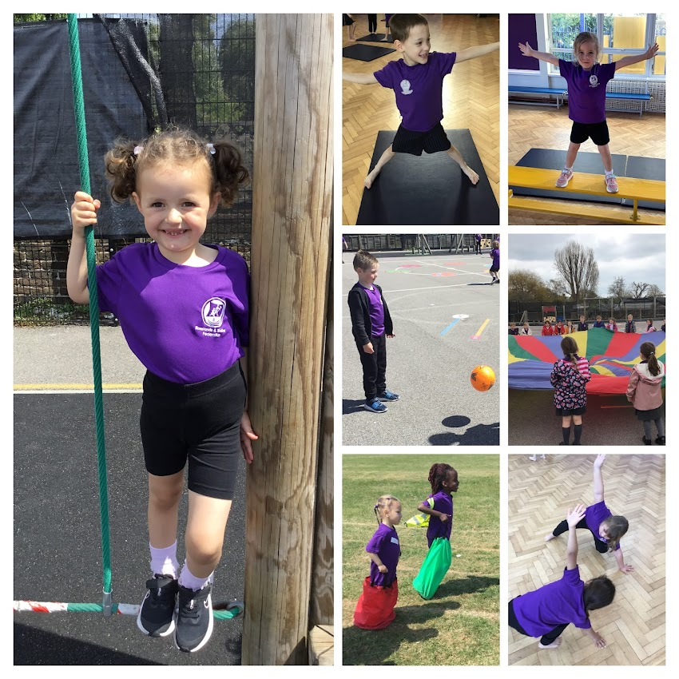
ROSELANDS INFANT SCHOOL

EVIDENCING THE IMPACT OF THE PRIMARY PE AND SPORT PREMIUM
2022-2023
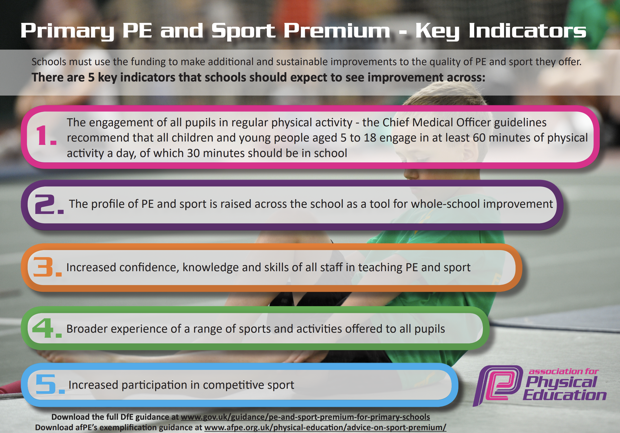

Support for review and reflection - considering the 5 key indicators from DfE, what development needs are a priority for your setting and your students now and why? Use the space below to reflect on previous spend, identify current need and priorities for the future.

Key achievements to date: | Areas for further improvement and baseline evidence of need:
- We are a Legacy School embedding the Create Development Framework.  - Teaching staff trained on using Real PE as part of the Jasmine curriculum. This included a showcase from a specialist teacher.  - All children are offered enrichment opportunities that enhance fitness levels and interest in physical activity.  - Staff CPD on Real Gym.  - Teachers teaching Real Gym lessons.  - PE subject lead given 3 days of extra CPD on how to lead and drive the new scheme.  - Successful sports days completed for all year groups.  - Highly effective collaboration has taken place between PE leaders across the Federation & the Cavendish partnership.  - Children have participated in a range of competitive events. | - Improve staff subject knowledge in dance.  - Develop an assessment tracking system to raise standards in PE.  - Staff CPD on Real Dance  - Work more closely with parents to enthuse, engage and develop a positive attitude to physical activity.  - Set up and introduce the ‘Bursts’ app which will encourage children to become more active at home.  - Devote more time / PDM to feedback from courses, discuss PE, embed active learning and raise profile more consistently.  - Improve lunchtime provision so that more children are engaged in active play.  - Apply for the Quality Start Award.

Action Plan and Budget Trac
Action Plan and Budget Tracking
Capture your intended annual spend against the 5 key indicators. Clarify the success criteria and evidence of impact that you intend to measure to evaluate for students today and for the future.

Capture
Academic Year:2022-2023 | Total fund allocated: £17,760  Extra funding allocated: £6000  Total fund allocated: £23,760  Total spent: £23,394.59 | Date Updated:  July 2024
annual spend against the 5 key indicators. ClAction Pl
Key indicator 1: The engagement of all pupils in regular physical activity – Chief Medical Officer guidelines recommend that primary school children undertake at least 30 minutes of physical activity a day in school |  |  |  | Percentage of total allocation:
 |  |  |  | %
School focus with clarity on intended impact on pupils: | Actions to achieve: | Funding allocated:  £6735.80 | Predicted Evidence and impact: | Sustainability and suggested next steps:
Engage children in regular physical activity  Playground zones to be developed to encourage physical activity. Sport leaders to be introduced and be part of this. | Purchase equipment to add to the playground markings.  Sports leaders to support at lunchtimes.  Markings to be put down in the EYFS area to encourage children to use the scooters and bikes.  New Building equipment to encourage daily physical activity outdoors. | £1715.00 - Playground equipment and markings  £5020.80  Equipment for EYFS outdoor area. | BASELINE DATA SEPT 2022  A Pupil survey showed that children wanted more activities at lunchtime.  A Pupil survey showed that children wanted to be more active at lunchtime.  EYFS baseline - Gross Motor skills  82% of children at baseline on track for achieving GLD at the end of the year.  Sports leaders to help support at activities at lunchtimes.  EVIDENCE (SUCCESS CRITERIA):  - 96% of EYFS received GLD in Gross Motor skills.  - EYFS children using the new construction equipment on a daily basis. This has helped children to improve their fine and gross motor skills as well as been more physically active. The new equipment has also helped to promote critical thinking and problem solving. Evidence of this can be seen in Tapestry observations.  - Children using playground markings at lunchtimes.  - Children selecting and accessing activities independently.  - EYFS children using playground markings everyday drawing free flow.  - Pupil voice.  “ I like going on the track on the scooters. It gives me more energy.” Harry EYFS  “I like the building. I have lots of different things. I have made a boat and a spaceship, the spaceship was so big.” Wilf EYFS  “I like it when we make our own races on the track, me and Benji do that with our friends.” Reggie EYFS .  “I use the playground games at lunchtime. I like the target games and the long jump” Ernie Year 2  “I am Sports Leader. I like helping run the dancing. I like helping children to play different games.” Keila Year2. | - Model how to use the playground markings at the start of each term to the children and have reminders of how to use them in assembly.  - Boxes put out with equipment at the markings that need them.  - Select new Sports Leaders to help promote the games at lunchtimes.
an and Bu

Key indicator 2: The profile of PE and sport is raised across the school as a tool for school improvement. |  |  |  | Percentage of total allocation:
 |  |  |  | 21%
School focus with clarity on intended impact on pupils: | Actions to achieve: | Funding allocated:  £4990 | Predicted Evidence and impact: | Sustainability and suggested next steps:
Ensure children have sufficient equipment to participate effectively in all curriculum PE. | - Staff CPD on Jasmine as a refresher and staff training on Real Gym and Dance.  - Engage in PE leadership programme  - Introduce staff to using the learning cogs which is part of the Jasmine PE programme  - Link the learning cogs to the schools Pillars of learning  - Introduce PE assessment tracker  - Purchase new equipment to engage children in the PE curriculum. | Jasmine Legacy Support for 2 years - £4990 | BASELINE DATA SEPT 2022  Baseline assessment of equipment available and needs analysis from the new PE JAsmine curriculum and staff voice.  44% of teachers felt confident using the Jasmine platform.  44% of teachers felt confident in their subject knowledge in Real PE.  Three new teachers had started who needed training.  100% of teachers wanted Dance training.  EVIDENCE (SUCCESS CRITERIA):  - Roselands is a Legacy School  - CPD training for teachers. Teachers watched a REAL Dance lesson being taught. After this CPD teachers 100% of teachers felt more confident teaching staff.  - After CPD training 100% of teachers felt confident using the Jasmine Platform.  - Gym and Dance Jasmine lessons are introduced into the school this year.  - Team teach support lessons were run by Jasmine specialists.  - 100% of PE lessons observed by Jasmine specialist and PE lead were good or better.  - Confidence: 100% of teachers feel more confident in teaching PE  - Subject knowledge: 100% of teachers are confident in teaching Real PE and using the platform.  - Teacher voice:  “I found the team teach sessions really useful and supportive. I feel much more confident in teaching Real PE and using the platform.”  “I enjoyed the Dance PDM. I feel more confident teaching it and can see how easily it links to what we are already doing.”  - Pupil Voice:  “I like PE lessons. I like the challenges and it is good to challenge yourself. I really like gymnastics.” Honey Year 2  “I like PE, it is always fun. I like that the lesson gets more challenging.” Matilda Year 2  “I like when we use the equipment. I like the challenges and sometimes they are hard. I really liked the dance.” Ernie Year 2 | - Continue to audit and ensure adequate resources are provided in order to provide a range of experiences for the children in school and during extra-curricular provision.  - Send a staff survey at the start of the year to find out what staff would like support with.  - Arrange CPD and learning walks to support the staff.  - Arrange training for using the assessment tool.
dget Tracking
Key indicator 3: Increased confidence, knowledge and skills of all staff in teaching PE and sport |  |  |  | Percentage of total allocation:
 |  |  |  | 3.5%
School focus with clarity on intended impact on pupils: | Actions to achieve: | Funding allocated:  £821.91 | Predicted Evidence and impact: | Sustainability and suggested next steps:
Develop staff CPD programme through: Create Development PE Scheme (Real PE) And become and begin Next Steps (3 years). | - Provider to meet with PE Lead to discuss CPD sessions timetable for the year.  - PE Lead to liaise trainers for whole school sessions .  - PE Lead to go on Real Leaders training  - PE Lead to complete learning walks with provider  - Equipment purchased to ensure the same quality of lessons are happening inside and outside  - PE kits purchased to ensure all children take part in PE lessons. | £821.91- New equipment for PE Lessons | BASELINE DATA:  Baseline set from Term 2 learning walks  Staff survey - Staff asked for CPD and team teach sessions.  Staff training needed for new staff.  EYFS teachers to begin using REAL Foundations in continuous provision.  EVIDENCE (SUCCESS CRITERIA):  - Team teach sessions run in Term 3. These were in Real PE, teaching a lesson and using the Jasmine Platform. 100% of teachers feel more confident using the platform when teaching.  - New staff members received logins and training on how to use Jasmine.  - All teachers are confident in using the learning cogs and learning nutrition to support lessons.  - Teacher voice  - EYFS teachers teach a Real Foundations lesson three times a week. | - Staff are more confident in teaching PE and ready to work on using the cogs and learning nutrition in lessons next year.  - Develop staff CPD programme through: Create Development PE Scheme (Real PE)  - Run a staff survey at the start of the next academic year to find out what staff want support with.  - Arrange CPD for staff.  - Arrange training for assessment.

Key indicator 4: Broader experience of a range of sports and activities offered to all pupils |  |  |  | Percentage of total allocation:
 |  |  |  | 45%
School focus with clarity on intended impact on pupils: | Actions to achieve: | Funding allocated  £10,701.09 | Predicted Evidence and impact: | Sustainability and suggested next steps:
School focus with clarity on intended impact on pupils:  Children to experience new sports and dance activities.  Children attend outside workshops to learn new skills and give the opportunities to learn outdoors which will help their mental health. | - Whole school to attend a Sports Day at Stafford Junior school  - Each Year group to attend six wider curriculum days  - West End in Dance to run dance workshops which link to key texts.  - Schools Without Walls to run outdoor sessions.  - Outdoor meadow to be improved so that more lessons can be run outdoors.  - Karate sessions run to enable children to try out and learn a new sport.  - Skilltech to run Gymnastic sessions for the children.  - SkilTek and Sports Cool to run multi-sport sessions to enable children to practise key fundamental skills. | Sports day -  £337.06  Meadow work- £400  Enrichment Days:  Schools without Walls. £4,050  Westend in Schools £1,864.03  Sports Cool - £1,800  SkilTek and Karate- £2,250 | Predicted Evidence and impact:  BASELINE DATA  Tapestry observations  Baseline assessment  Pupil voice  Class survey  EVIDENCE (SUCCESS CRITERIA):  - All children across the school took part in enrichment days.  - Children had the opportunity to learn new skills and work outdoors.  - Children took part in a dance workshop which was linked to a key text. This was then used to engage children in writing.  - Children took part in Schools without walls which taught the children ways to use the outdoors in a physical way.  - Children have taken up karate as an after school club after the sessions at school.  - Pupil Voice  “I liked Learning karate. I had never done it before.” Rae EYFS  “I now go to karate.” Harry Year 1  “I really liked yoga.” Aurora EYFS  “ I liked doing karate and I am going to do it again now.” Dougie Year 2  “I love the enrichment days and they are really good run. I liked the West End Dance. We learnt a dance to Charlie and the Chocolate Factory. I am reading that book.” Matilda Year 2 | School focus with clarity on intended impact on pupils:  - Children to experience new sports and dance activities.  - School TA now runs outdoor learning sessions after attending Schools without Walls sessions.  - Set up a rota for using the meadow.
Key indicator 5: Increased participation in competitive sports |  |  |  | Percentage of total allocation:
 |  |  |  | 0.6%
School focus with clarity on intended impact on pupils: | Actions to achieve: | Funding allocation £145.79. | Predicted Evidence and impact: | Sustainability and suggested next steps:
School focus with clarity on intended impact on pupils:  Children to attend inter school competitive activities. | Actions to achieve:  - Roselands to join PE association  - Year 2 children to attend football festival  - Year 1 children to attend handball festival  - Al children to attend a whole school sports day at Stafford Junior School | Mini bus hire £40  Supply cover £105.79 | Predicted Evidence and impact:  In a pupil survey children said they would like to attend more sporting events.  EVIDENCE (SUCCESS CRITERIA):  Pupil voice  Newsletter  Tapestry observations  Photos  - Year 2 children attended a football and handball festival.  - All the whole school took part in a Sports Day.  - Pupil voice:  “I really liked Sports day. I liked the egg and spoon race.” Dougie Year 2  “Sports day was good fun. I liked the water race best and my Mummy came to watch me.” Isabella Year 1 | - Children playing handball after attending a handball event.  - To get the school involved in more inter- school festivals and competitive sports.  - To set up in school competitions.  - Run a competitive activity at lunch time.

Budget | £23,760
Final Spending | £23.394.59
Balance | £365.41

Approved by the Local Governing Board
Signed by | Name | Signature | Date
PE Leader | Natalie Harrison |  | 16.7.2023
Executive  Headteacher | Kyra Siddall-Ward |  | 17.7.2023
Chair of Governors | Denise Kong |  | 17/7/2023

